COMP 7500 - Lecture 11: Multilevel Queue Scheduling
: >85%, : 70-85%, : 55-70%, : 40-55%, : < 40%

Exercise 1 (MS Forms): If a scheduler offers an average turn-round time of 20 second, what is the throughput of this scheduler?
- 0.5 No./Second
- 0.05 No./Second
- 0.5 Second/No.
- 20 Second/No.

Exercise 2:
(2.1) Please propose two separate ready queues? (Hint: for different types of processes).

(2.2) What are scheduling policies these two queues?

Exercise 3: In multi-level queue scheduling, which queue has the highest priority and which queue has the lowest one?

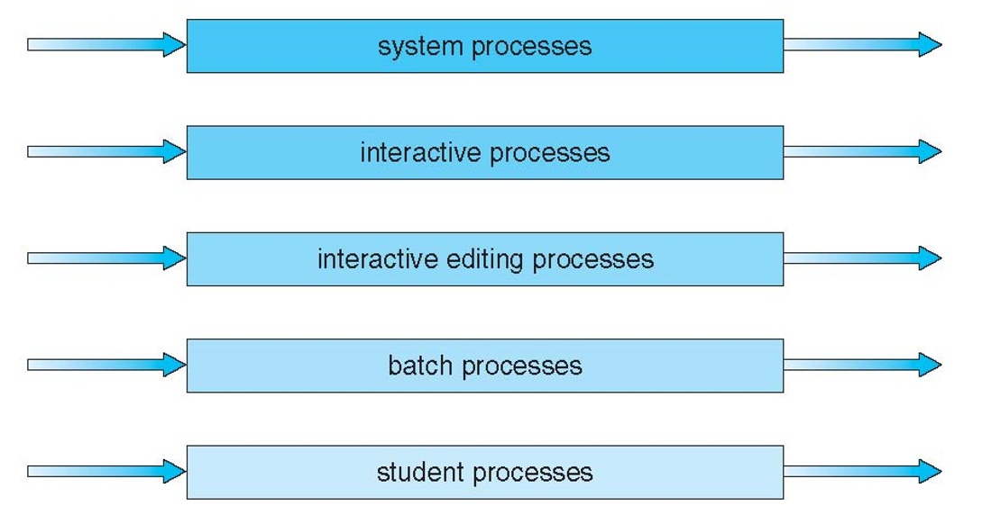

Exercise 4: How to schedule between the two queues (i.e., interactive queue and batch queue)? (1 Minute)

Exercise 5: Please setup the following parameters for a multilevel-feedback-queue scheduler.
- The number of queues: ________________
- Scheduling algorithm for each queue? Yes or No
- Method used to determine when to __________ a process
- Method used to determine when to __________ a process
- Method used to determine __________ a process will enter when that process needs service

Exercise 6 (MS Forms): In the multilevel-feedback-queue scheduler, which queue has the highest priority?

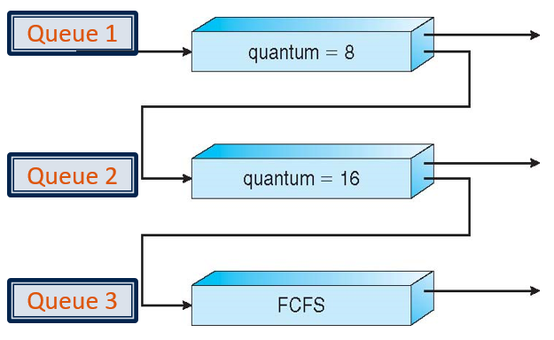
- Queue 1
- Queue 2
- Queue 3
- Queue 1 and Queue 3

Exercise 7 (MS Forms): Which one of the following statement about the multilevel-feedback-queue scheduler is incorrect?
- Processes in Queue 1 may starve
- Processes in Queue 2 may starve
- Processes in Queue 3 may starve
- Some processes may starve

Exercise 8: Please propose a solution to the problem described in Exercise 7.

